**Brooklyn torah gazette**

**For parshas nasso 5779**

Volume 3, Issue 41 (Whole Number 137) 12 Sivan 5779/ June 15, 2019

**Printed L’illuy nishmas Nechama bas R’ Noach, a”h**

For a free subscription, please forward your request to [***keren18@juno.com***](mailto:keren18@juno.com)

**How to Make Your Visit**

**To Eretz Yisroel Special**

**By Daniel Keren**

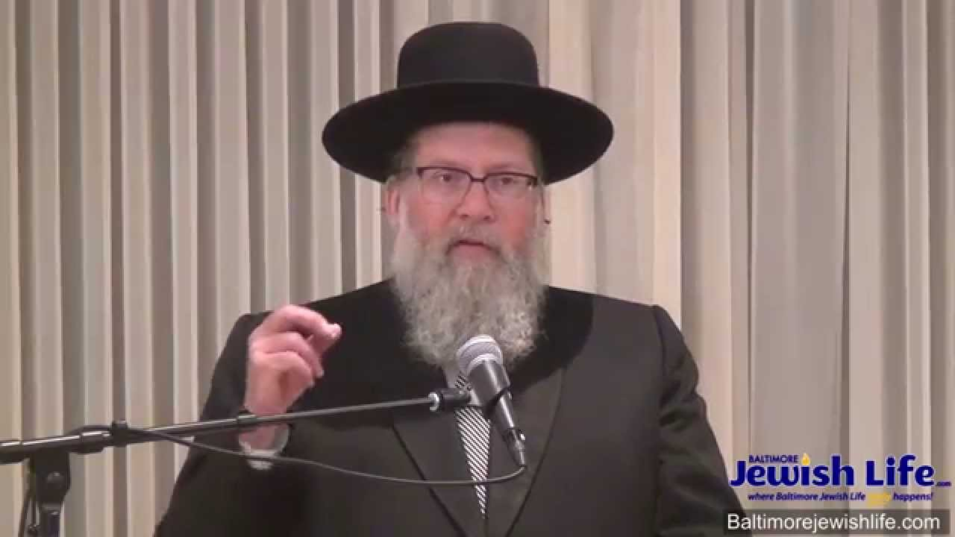

One of the featured speakers at last month’s Hakhel Memorial Day Yarchei Kallah was Rabbi Moshe Tuvia Lieff, Mora D’asra of the Agudas Yisroel Bais Binyomin shul in Flatbush. He addressed the topic of “Visiting Eretz Yisroel: Practical Halachos and Hashkafos.”

Rabbi Lieff spoke about how our grandparents and earlier generations who could only dream of visiting Eretz Yisroel had a greater reverence for the Holy Land. One hundred years ago the Promised Land was so close, yet so far away. Today, it is easier to travel to Israel, but the reverence that a Jew should properly feel is so ironically far away from us.

He noted that many of us are today excited by being in the Kosel Plaza (near the Western Wall remnant of the Bais Hamikdosh). Yet, they have forgotten that our true dream should be for the restoration of our holy Temple that once stood in all its glory in Yerushalayim.

**The Importance of Have a Proper Reverence for the Kosel Hamaravi**

There are people whose reverence for the Kosel Hamaravi was so strong that they would walk backwards when leaving this great makom hakodesh (holy spot). Yet others today have a more cavalier attitude and without thinking loudly call for all their family members to get together for a photo op, even though this would necessitate their backs to the wall.

Rabbi Lieff challenged the audience at the Memorial Day Hakhel Event with the question: “How can you not prepare yourself for a visit to Eretz Yisroel?” He insisted that one should make sure to only go on a tour conducted by a frum tourist guide. Otherwise a secular guide with no appreciate for the holiness of the land or holy sites will give you a corrupted and misguided view of Eretz Hakodesh.

One should never call the Western Wall, the holiest site in Judaism the “Kosel, (Wall.) It is the Kosel Hamaravi. Rabbi Lieff said that to call it just the “Kosel” is a degradation. When facing the Kosel Hamaravi, make sure that you don’t look at the mosque [atop the Temple Mount] when bowing [during your prayers.]

Rabbi Lieff noted that there is a minhag to recite Kapital Ayin Tes (Chapter 79) of Tehillim (Psalms) when visiting the Kosel Maaravi. One should not meet or greet friends and others you know when visiting the Western Wall.

**The Insight of Rabbi Shlomo Zalman Auerbach**

Today there are many beautiful buildings, shuls, yeshivas and hotels in Jerusalem and one might think that everything is wonderful. However, Rabbi Lieff noted that Rabbi Shlomo Zalman Auerbach, has said that since there are still churches in Yerushalayim and there other things occurring in the Holy City (i.e. To’eva marches just a mile from the Kosel Maaravi) we are still in a status that the Ir Hakodesh is in Chorev (ruins) and that we are still in a bitter galus (exile.)

When doing kriah (tearing one’s garment) at the Western Wall in mourning for the loss of our Beis Hamikdosh, Rabbi Lieff said one need not do it on an expensive suit or coat. One could take off the suit or coat and do it on a shirt. When doing a kriah, one must do so standing. If you do it sitting, that isn’t acceptable and one needs to make the tear in the garment again.

Also when visiting kevarim (gravesites) of tzedakim (righteous Jews) chas v’shalom (G-d forbid,) one should never pray to the tzadik to help him That is kefirah (heresy.) Rather one davens to Hashem with the hopes of being answered by the merit of the tzadik that will facilitate one’s prayers ascending to our Father in heaven.

*Reprinted from the June 6, 2019 edition of the Flatbush Jewish Journal.*

**Rav Avigdor Miller on**

**Saying “You” to Hashem**

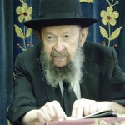

**QUESTION:** What is the most important thought that one should have when making a *bracha*?

**ANSWER**: The answer is "*Atah Hashem*." That's number one! You're not just saying a *bracha -* you're talking to somebody. The Mesillas Yesharim says that it's not an easy thing to gain that attitude and to impress on your mind that somebody is actually listening.

But when you put effort into it - when you keep on trying - after a while it's possible to gain that attitude that Hashem is right in front of you and is listening. "*Ki atah shomei'ah*" - You are listening to "*amchah Yisroel b'rachamim*."

Yes; You are listening. You are really listening. The truth is that He *is* listening - no question about it - but you have to work on gaining that true attitude. Don't wait for it to come by itself.

And therefore that's the first and most important attitude required for making a *bracha*. Not the *peirush hamilos* but the true attitude of "*Atah* *Hashem*" - "You Hashem." He is listening. "I am talking to You, Hashem."

And the second important *kavanah* is to thank Hashem. I am thanking You Hashem. It's not enough just to know what you are saying but you should actually feel a debt of gratitude to Hashem. Thank Hashem for the favor that He has bestowed on you. Let's say you're saying *pokei'ach ivrim - "*You open the eyes of the blind."

Oh, what a favor that is! Suppose Hashem didn't give you the ability to see. What a tragedy, *chalilah* that would be. To live a life in total darkness. What a pity; what a pity that would be. So you are filled with happiness that you can see and you actually should feel a debt of gratitude to Hashem.

And therefore once more: The first thing that you must work on is gaining the attitude that you are speaking directly to Hashem and that He is listening. And the second thing is that you are thanking Him and that you appreciate what you are thanking Him for.

Don't make a *bracha* just to be *yoitzei*. It's better than nothing. But not much better.

*Reprinted from the May 27, 2019 email of Toras Avigdor (Tape #E-213).*

**The Importance of a Jew**

**Giving His Best to G-d**

**From the Talks of the Lubavitcher Rebbe**

**Rabbi Menachem Mendel Schneerson, Zt”l**

"And every offering of all the holy things...which they bring to the kohen, shall be his," states the Torah in this week's portion, Naso.

"This refers to bikurim (first fruits)," explains Rashi, the great Torah commentator.

The very first fruits to ripen are to be brought to the Holy Temple in Jerusalem and given to the kohen (priest), as his due.

Agricultural produce does not grow by itself.

In order to produce those fruits a Jew must toil countless hours painstakingly plowing, sowing and tending his fields. Yet instead of enjoying for himself the first tangible results of his labor, the Torah demands that they be brought to Jerusalem and presented to a total stranger!

We learn from this that the very first and best of whatever a person possesses should be used for the purpose of tzedaka (charity).

Many people don't find it too difficult to accept this principle when it comes to supporting religious institutions.

They give willingly when asked to contribute to a synagogue or yeshiva.

But a strange thing occurs when it comes to giving tzedaka to a needy individual: "Why should I part with my hard-earned money to support him?" the Evil Inclination prompts us.

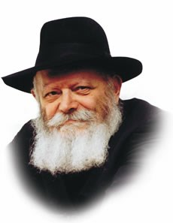

**The Lubavitcher Rebbe, zt”l**

"Why should his needs come before mine? Why must I part with the very best? Is not second best good enough? Better I should take care of myself first, and only afterward help others with whatever is left over."

We learn, however, from the mitzva of bikurim, that such is not the Jewish way.

We are commanded to give the first fruits to the kohen, an individual, for his own personal use. Only after this is done are we permitted to derive benefit from the blessings G-d has given us.

Significantly, the Torah commands us to bring the first fruits to the Holy Temple, "the house of the L-rd your G-d" in Jerusalem before presenting them to the kohen.

A Jew must first understand that whatever wealth is granted him from Above is not truly his, despite the labor he may have invested to amass it.

When a Jew realizes that everything, in reality, belongs to G-d, the protests of the Evil Inclination are silenced, and it is far easier to part with the "first fruits" of one's earnings even for another individual.

*Reprinted from the Parashat Naso 5754/1994 edition of L’Chaim Weekly (Issue #263), a publication of the Lubavitch Youth Organization in Brooklyn, NY.*

**Rabbi Berel Wein on**

**Parashat Nasso**

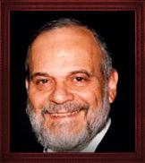

The Torah reading this week begins with a commandment to Moshe to count the Levites, especially the family of Gershon. The Hebrew words that are used to make this count, literally translated, mean “raise the head” of the family of Gershon, who are an important section of the tribe of the Levites.

There are many different interpretations as to why the Torah chose to use this formulation of words to indicate a count of that family. The Torah certainly could have used a simpler and more direct verb to indicate to Moshe that he was to take a census of that family of the Levites.

I remember that when I attended law school long ago, we students had to prepare the cases that would be discussed in the lecture of the professor for that day. The professor had a very prickly personality and oftentimes was even slightly inebriated when teaching the class. His methodology was to call upon a student to read and discuss a case at first before expounding upon what principle of law that case illustrated.

The professor was very short tempered and usually skewered the hapless student attempting to read and explain the case. Because of this, no one in our class ever wanted to volunteer to read the case and lead the discussion about it. So, at the beginning of every class all of us had our heads lowered and refused to make any eye contact nor any other apparent physical connection with the professor. He was, hands down, a terrible person and we put our heads down to avoid having to deal with him.

Perhaps this is the reason why the Torah use this phrase of ‘raising the head’ when discussing the role of the Levites in Jewish public life and their tasks in the service of the Temple and the Tabernacle. It is a privilege to be a Levite, to be in the service of the God of Israel and the people of Israel. It is a matter of pride and accomplishment and not to be viewed as a burden or something to be minimized. One has to volunteer enthusiastically for the work in the service of God in Israel.

If one is proud and enthusiastic about one's role within the Jewish community and sees one’s self in the perspective of generations and tradition, as doing holy work and contributing to eternal projects, can one really feel the pride and joy of being a Levite… and in fact, of being a Jew.

The Torah abhors slackers. Those who attempt to escape or avoid the necessary commitment and effort to be Jewish and to serve the cause of Jewish survival and success eventually are not destined to remain part of the eternal people. Jewish history testifies to this basic fact of Jewish life. Only by raising one's head and, in effect, saying count me in, can one expect the blessings of eternity.

*Reprinted from this week’s website of Rabbiwein.com*

**The Shmuz on****Parshas Nasso**

**I Never Do Anthing Wrong**

**By Rabbi Bentzion Shafier**

**Founder of TheShmuz.com**

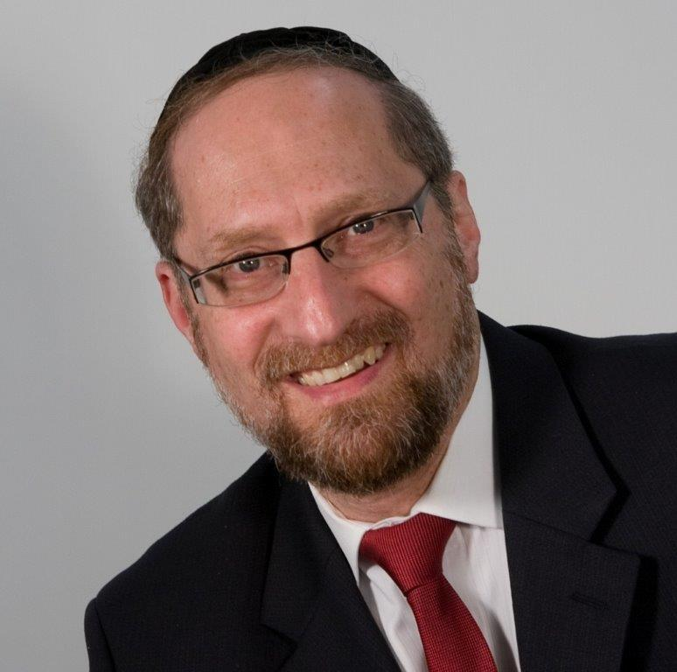

**Parshas Nasoh**

*“Speak to the Bnai Yisrael and say to them: any man whose wife shall go astray and commit treachery against him. . . ”* — Bamidbar 5:12

**The Parsha of Sotah**

The Torah describes the details of a *sotah*. If a woman acts in a manner that causes her husband to suspect her of infidelity, he should warn her not to go into seclusion with that other man. If she violates this warning, then the husband is to take her to the *Kohain*. The *Kohain* will give her the “bitter waters” to drink. If she was unfaithful, she will instantly die. If she was not unfaithful, she will be redeemed and blessed.

When the Torah lays out the details, it uses an unusual expression: כי תשטה “If a man will ‘*tistheh’* his wife.” The word “*tishteh*” comes from the root “*shoteh*,” which means insanity. It’s as if to say, “If a man will accuse his wife of insanity.”

Rashi is troubled by the use of this expression. He explains, based on the Gemara, **adulterers do not sin until a wave of insanity enters them**. The *Siftei Chachmim* explains this to mean, “until their *yetzer* *harah* teaches them it is permitted.”

It seems clear from the *Siftei Chachaim* that the *modus operandi* of the *yetzer harah* is to convince the potential sinners that the act tempting them is permitted. Only when it succeeds, and they are convinced, will they then transgress.

This statement — people only sin when they are convinced that it is permitted — seems difficult to understand. If we are dealing with a pious, proper Jewish woman who got into a bad situation, she knows that the act that she wants to commit is forbidden. How can the *yetzer harah* teach her that it is permitted? On the other hand, the Torah may be speaking about the opposite extreme — a woman who has gone off the path and just doesn’t care. Why does she need the *yetzer harah* to tell her it is permitted? She doesn’t care.

So on both sides of the spectrum, the *yetzer harah* either should not be able to convince the person that it is permitted, or it shouldn’t need to convince them.

**I never do anything wrong**

The answer to this question is based on understanding one of the most consistent quirks of human nature: “**I never do** **anything wrong.”** Whether dealing with sophisticated adults or schoolchildren, whether Supreme Court justices or convicted felons, the human seems never to do anything wrong. Wardens will tell you that their jails are filled with self-proclaimed innocent men. Criminals aren’t wrong. Thieves aren’t wrong. Murderers aren’t wrong. You won’t find a gangster proclaiming, “Yes, it is evil to murder and pillage, but what can I do? I am weak and give into my desires.” Instead, you will hear an entire belief system explaining that his approach to life is actually better for society and the world.

The question is why? Why can’t man just admit: it is wrong to steal, but I want to do it anyway?

**The inner workings of the human**

The reason for this has to do with the inner working of the human. HASHEM created man out of two distinct parts. One is comprised all of the drives and passions found in the animal kingdom; it is simply base instincts and desires. The other part of man is pure intellect: holy, good and giving. That part of me wishes to be generous and noble and only aspires for that which is good.

Because this part of me is made up of pure intellect and wisdom, it would never allow me to sin. It sees the results too clearly. It understands that all of HASHEM’s commandments are for my good and that every sin damages me. Because of this crystal clear insight, the human would not have the free will to sin. In theory, he could be tempted to sin, but he would never actually come to the act. It would be akin to sticking his hand in a fire. In theory he could do it, but it would never happen. It’s a dumb thing to do. So if HASHEM created man with just these two parts, man would not have free will in a practical sense.

To allow man to be tempted so that he can choose his course and be rewarded for his proper choices, HASHEM put another component in man: **imagination**. Imagination is the creative ability to form a mental picture and feel it as vividly **as if it were real**. Armed with an imagination, man can create fanciful worlds at his will and actually believe them.

If man wishes to turn to evil, he can create rationales to make these ways sound noble and proper — and fool himself at least. If he wishes, he can do what is right, or if he wishes, he can turn to wickedness. Even his brilliant intellect won’t prevent him. He is capable of creating entire worldviews that explain how the behavior he desires is righteous, correct, and appropriate. Now man has free will.

The answer to the Rashi is on two levels. First off, we see the power of rationalizing. Even a fully mature, pious woman who grew up in the best of homes can be convinced, on some level, that illicit relations are permitted. The *yetzer harah* will use her imagination and create clever and creative ways to explain that black is white, in is out, and *arayos* is permitted. As ridiculous as it sounds, that is the power given to the *yetzer harah*.

The second idea is that even the woman who seems to be off the *derech* and wouldn’t need an excuse really does. No human can ever do something that is wrong. Because of the greatness of her soul and the truth that she knows deep down inside, she understands that for a married woman to go to another man is forbidden. The only way that she can perpetrate this act is if she has a rational way of explaining how in fact it is permitted. The human is incapable of doing something wrong. The only way he can do something wrong is by making it right.

*Reprinted from this week’s website on TheShmuz.com This is an excerpt from the [Shmuz on the Parsha book](https://theshmuz.com/product/shmuz-on-the-parsha-book/).*

**At the Beginning**

**Of Each Week**

**By Rabbi Moshe Meir Weiss**

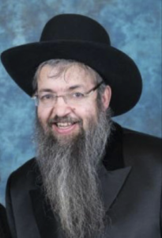

Every Motzoei Shabbos, the communal highlight of our sacred havdalah service is the public chanting of the posuk, “LaYehudim hoisa ora v’simcha,v’ soson v’yakar – And to the Jews there was light and joy, exultation and honor.”  Then, we cap-off all this with the prayer, “Kein tihye lonu – So it should be for us.”  Most people who say this have their focus (correctly) on the simcha and soson, happiness and joy, at the beginning of the week and beseech that the coming week should be a happy one, filled with all kinds of joy.

But, as we know, in this verse there lurks much more.  The Gemora in Masechtas Megillah breaks down this posuk and teaches us ora, light, refers to Torah; simcha, happiness refers to Yomtov; soson, exultation, denotes milah; and yakar, honor signifies tefilin.

The Sfas Emes, Zt”l, Zy”a, asks the obvious question:  Why doesn’t the posuk say what it means?  Why don’t we just say, “And to the Jews there was Torah, Yom Tov, milah and tefilin?”  Why use code words?  He answers that the posuk found in the Megillah refers to the state of Jewish mind after the miracle of Purim.  It was then that they realized that Torah was their true light, that Yomtov was the source of happiness, milah was something to exult in and tefilin was the height of Jewish honor.  It is this correct passion and meaningful religiosity that we wish for in the beginning of the week.

The first thing we ask for is ora, the light of Torah.  We pray that the guiding light of the Torah should illuminate our home.  To appreciate what this means, picture yourself in a room full of obstacles, pitch blank and with no windows.  Without the benefit of light, one is certain to stumble and hurt oneself.

The same thing is true in the way we lead our lives.  If we live without the direction of the Torah, we are certain to stumble.  If we don’t have the Torah’s warning against vengeance and bearing grudges, we are likely to suffer in our interpersonal relationships.  If we don’t have the Torah’s inhibitions against false weights and measures, lying, usury, cheating, we are likely to tumble in our business dealings.

Without the Torah’s commandments of kivud av v’eim – honoring parents, and v’shinantom livonecha – teaching our children, v’ahavta l’rei’echa kmocha – treating out friends the way we want to be treated ourselves, lo sitnah es achicha bilvovecha – do not hate your fellow in your heart, v’asisa hayoshor v’hatov – and do that which is upright and good, we are likely to mess up our relationships.

A young man once approached Rav Shteinman, Zt”l, Zy”a, and asked him why it was that he did not find sweetness in his Torah learning.  After all, the posuk says that the Torah is compared with brilliant light m’sukim m’dvash, and is sweeter than honey.  Why was it that he was learning for many years and couldn’t wait until the day was over, until he could close his Gemora and leave the Beis Midrash?

Rav Shteinman asked him a different question:  When does honey not taste sweet to a person?  When the young man looked puzzled, Rav Shteinman answered that it was when a person has sores on his tongue.  If this were the case, the honey would hurt and sting.

Rav Shteinman said that it’s the same thing with that which is spiritual.  If we have spiritual sores in our mouths such as the sin of lashon hara – sinful gossip, nivul peh – being vulgar, sheker – lying, or onaas devorim – saying hurtful things to people, or if we reveal peoples secrets, then the spiritual sores in our mouths do not allow us to taste the sweetness of Torah we speak and learn.

I would like to elaborate on Rav Shteinman’s idea.  If our hearts are full of hate and jealousy, our heart cannot embrace the sweetness of Torah.  If our minds are full of impurities, they cannot then appreciate the beauty of Abaya and Rava, Ravina and Rav Ashi.

So, at the beginning of the week when the family in unison says “Kein tihye lonu,” we should have in mind that the light of the Torah should be allowed entry into our homes, our hearts and our minds.

Rav Zelig Pliskin, in his beautiful sefer on marriage, cites a custom that some couples have.  Right after Shabbos, they each light a candle and for a moment they say a quite prayer that they should each have the merit to bring light into their partner’s life during the coming week.

May it be the will of Hashem that the glow and the warmth of the fire of the Torah should be ablaze in our homes and in that merit may Hashem grant us long life, good health, and everything wonderful.

*Reprinted from the February 14, 2016 website of Matzav.com*

**The Power of Teshuba**

**Rabbi Eli J. Mansour**

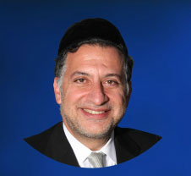

The Torah in Parashat Naso speaks of the case of a thief who falsely denies his crime on oath and then wishes to repent. In such an instance, the Torah instructs, “Ve’heshib Et Ashamo Be’rosho Va’hamishito Yosef Alav” (5:7).  Literally, this means, “He shall return what he is guilty of, its principal, and then add onto it one-fifth.”

The meaning of the Pasuk is clear – the penitent criminal must repay the stolen sum plus an additional fifth – but the Torah’s formulation seems puzzling.  It calls the stolen money “Ashamo” (literally, “his guilt”), and refers to the principal sum as “Be’rosho” (literally, “at its head”). In light of this unusual wording, scholars throughout the ages have unearthed deeper layers of meaning underlying the text of this Pasuk.

One approach connects this Pasuk to the Gemara’s comment in Masechet Aboda Zara (5).  The Gemara there states that every Misva we perform produces an angel that “walks in front of us” to the next world, whereas every sin we commit creates an angel that “embraces us” and leads us to punishment, Heaven forbid.

The Maharsha (Rav Shmuel Eidels, 1555-1631) explains this passage by drawing an analogy to a king who sends two servants – one to bring someone to his feast, and another to bring someone to the gallows.  The messenger bringing the man to the party walks in front of the man to lead the way, confident that the man follows him.  The servant leading the man to the gallows, however, must hold him tight to prevent him from escaping.

Similarly, the angels we create through our Misvot lead the way for us to Gan Eden, confident that we follow them.  But if, Heaven forbid, we create angels by committing sins, they will hold us tight and bring us to our punishment, preventing us from escaping.

The process of Teshuba, however, has the ability to change the angel’s mission.  The Gemara elsewhere teaches that Teshuba Mi’yir’a – repentance done out of fear – has the ability to “downgrade” our sins to unintentional violations, but “Teshuba Me’ahaba” – repentance out of love for Hashem – transforms our sins into sources of merit.

If we repent with sincerity, out of genuine love for our Creator which leads us to regret our wrongdoing, the misdeeds on our record are changed to Misvot.  And thus the angel taking us to be punished instead leads us to our reward.

It has been suggested that this is the meaning of the phrase, “Ve’heshib Et Ashamo Be’rosho,” which can be read as, “He moves his guilt in front of him.”  After one commits a sin, he has the ability to “move” his “guilt” – the angel – to his front.  The angel which was created through his sin can change roles and move in front of him to lead him toward his reward, as the sin is transformed into a Misva.

And thus this section of Parashat Naso is not just outlining the procedure for one who committed theft and denied it on oath. It conveys a message relevant to each and every one of us, as we are all guilty of mistakes of one kind or another. The Torah here teaches us never to despair, to never think that we are held captive by the wrongs of our past.

Even if now we are held in the clutches of the angel, and bear a heavy burden of guilt, G-d in His infinite mercy allows us the opportunity to release ourselves from its grasp, and change its role into an angel bringing us reward, as long as we repent sincerely and out of a deep sense of love and gratitude to the Almighty.

The angel does not allow us to escape – unless we repent with sincerity and make a genuine effort to lovingly return to the faithful service of Hashem, in which case it “lets us go” and leads us to our reward.

*Reprinted from this week’s website of the Edmund J. Safra Synagogue in Brooklyn, NY.*

**The Haredi Community**

**And Israel's Future**

**By Giulio Meotti,**

***The Haredi total devotion to intellectual and spiritual activities turned Israel not only into the start-up nation, but also in a global spiritual center.***

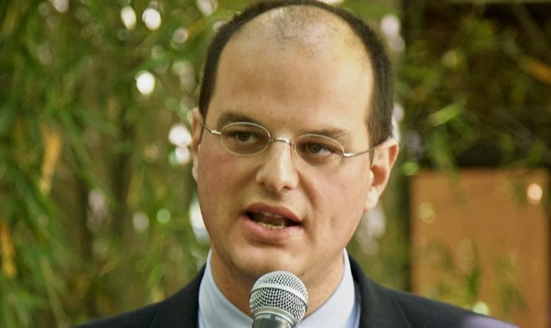

**Giulio Meotti**

A few years ago, Israeli sculptor Yigal Tumarkin stated that “when I see the black-coated haredim with the children they spawn, I can understand the Holocaust”. I quote his infamous words to remind all the Israelis who care about tolerance and respect that a huge segment of their society is not without sins. The Israeli press returned to talk about the haredim after Benjamin Netanyah's failure to form a new government. I want to repeat here what I penned last week.

During the Second Intifada, as in other hard times, many secular Israelis realized that their people needed a strong dose of haredi and religious Zionist stoicism to survive and thrive under the Israeli circumstances. No completely secularized society would have resisted for a minute.

The believers' insistence that everything has a purpose pressures them to always see the positive even in the darkest hours. The haredi total devotion to intellectual and spiritual activities turned Israel not only into the start-up nation, but also in a global spiritual center.

The world of Torah was in the process of being destroyed by the Nazis during the Shoah. Some scholars even suggested that the Orthodoxy in the XX century would have been consumed by the Enlightenment, Zionist and Socialistic secular Jewish movements and it retook the center of the stage because of the Shoah that nearly incinerated the religious Jewish world.

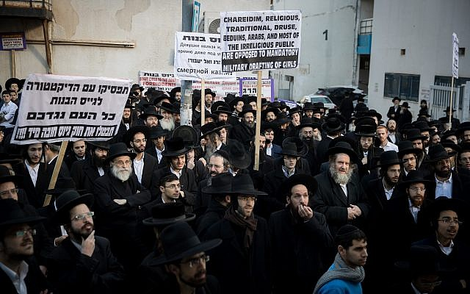

That should make the secular Israelis reflect about the very meaning of the “Final Solution of the Jewish people”. The haredim and religious Zionists perpetuated the lost Orthodox Judaism after the Shoah and refilled the ranks of Torah scholarship destroyed in the gas chambers.

How  would Israel keep Judea and Samaria – its Biblical heartland and defensive shield – without the haredim, who are 30 percent of the whole Jewish population living beyond the Green Line? In Beitar Illit, fully 66 percent of the 70,000 residents are under the age of 18. Even if the Haredim didn't move there for ideological reasons, their very presence and demographic force are fundamental today for keeping those lands under Israeli sovereignity.

The haredim and many religious Zionists visit day and night all the Jewish holy sites: Rachel's Tomb, Hevron's Cave of Patriarchs, Jerusalem's Kotel and Joseph's Tomb. I have seen their strength in those places with my own eyes. As I have seen that most of the victims of Hevron's pogrom in 1929 were Haredi Jews, those who kept a Jewish presence in that holy city for centuries.

Those who despise the Haredim usually don't stop there: they go on to despise modern Orthodox, religious Zionists, "settlers"... All those who go in the opposite direction the world would like the Jews to take. I have never found the Haredim narrow and dark, as the media like to portrays them. I met only humble and joyful people.

Hundreds of thousands of Jews after 1948 came to Israel not because it is a liberal democracy, but because it is a shelter and it is Eretz Yisrael. Torah scholarship was fundamental in keeping the Jewish tradition alive. In Israel there are thousands of *baalei teshuvah*, or “returnees”. And that is also a consequence of the importance of Orthodox Judaism in the Israeli society.

If the Jews have a future in Europe it will only be due to the presence of Orthodox Jews, who will refuse to hide and go underground.

If the Jews have a future in America it will only be due to the presence of Orthodox Jews, who will refuse to assimilate.

True, the secular and religious division is causing lots of tensions in the Israeli society. But to reach a healing, both must overcome the differences and appreciate their respective and unique contributions to the Israeli enterprise. And the haredi contribution to Israel is immense.

*Reprinted from the June 5, 2019 email of Arutz Sheva.*